

SITEM PENERIMAAN MAHASISWA BARU ULBI

Created on: 30 June 2023

htpps://admission.ulbi.ac.id

Created by: Marketing & Admission status of the document: Process

**Versions and signoff assertions:**

Test Plan History:

|  |  |  |  |
| --- | --- | --- | --- |
| **Version Num** | **Date** | **Author** | **Changes Summary** |
| 1.0 | 30 June 2023 | Yadi Mulyadi | User Interfaces |
|  |  |  |  |
|  |  |  |  |

Changes Approval:

|  |  |  |
| --- | --- | --- |
| **Name** | **Approved** | **Date** |
| Pradhana Wahyu Nariendra | Approved | 2 March 2023 |
|  |  |  |
|  |  |  |

SRS Document Reference:

|  |  |
| --- | --- |
| **Document Name** | **URL** |
| Business Requirements | <https://pmb.uisi.ac.id/> |
| Technical Requirements |  |

**Table of Contents:**

1. INTRODUCTION 3
   1. Project Overview 3
   2. Audience 3
2. TEST STRATEGY 4
   1. Test Objectives 4
   2. Test Assumptions 4
   3. Test Principles 5
   4. Scope and Levels of Testing 6
      1. Build Acceptance 6
      2. Functional Test 6

*Test Deliverables 6

* + 1. User Acceptance Test (UAT) 7

*Test Deliverables 7

* 1. Test Effort Estimate 8

1. EXECUTION STRATEGY 9
   1. Start and Exit Criteria 9
   2. Test Cycles 10
   3. Test Metrics 10
   4. Defect tracking & Reporting 11
2. TEST MANAGEMENT PROCESS 12
   1. Test Design Process 12
   2. Test Execution Process 12
   3. Test Risks & Dependencies 13
   4. Team Members Roles 13
3. TEST ENVIRONMENT 14
   1. Test stage 14
   2. Test Compatibility 14
4. DEADLINES AND DELIVERABLES 15

# INTRODUCTION:

## Project Overview:

Pendaftaran mahasiswa baru merupakan salah satu kegiatan perguruan tinggi. Hal ini memungkinkan ratusan bahkan ribuan calon mahasiswa baru untuk mendaftar di perguruan tinggi setiap tahun, termasuk di Universitas Logistik dan Bisnis Internasional (ULBI).

Universitas Logistik dan Bisnis Internasional (ULBI) hasil merger dari Politeknik Pos Indonesia (POLTEKPOS) dan Sekolah Tinggi Manajemen Logistik Indonesia (STIMLOG) Berdasarkan Surat Keputusan Menteri Pendidikan, Kebudayaan, Riset, dan Teknologi Republik Indonesia Nomor 334/E/O/2022 yang ditetapkan di Jakarta pada tanggal 24 Mei 2022. ULBI merupakan Perguruan Tinggi Pertama di Indonesia yang berfokus pada keilmuan bidang Logistik, Manajemen Rantai Pasok, E-Commerce, dan Bisnis. Berkaitan dengan hasil merger inilah yang menjadi dasar kelompok penulis ingin mengembangkan dan menyeseuaian sebuah sistem informasi untuk mendukung peroses kegiatan penerimaan

mahasiswa baru.

## Audience:

|  |  |
| --- | --- |
| Title/Department | Name |
| Marketing & Admission | Yadi Mulyadi |
| Marketing & Admission | M. Aldy RIpaldi |
| Marketing & Admission | Grahito Editya Rachman |
| Dir. Teknologi & Informasi | Fachrie Pane |
| Dir. Teknologi & Informasi | Indra |

# TEST STRATEGY:

## Test Objectives:

This is a dummy text This is a dummy text This is a dummy text This is a dummy text This is a dummy text This is a dummy text This is a dummy text This is a dummy text This is a dummy text

## Test Assumptions:

* + - This is a dummy test objective text
    - This is a dummy test objective text
    - This is a dummy test objective text
    - This is a dummy test objective text

## Test Principles:

* + - This is a dummy test objective text
    - This is a dummy test objective text
    - This is a dummy test objective text
    - This is a dummy test objective text
    - This is a dummy test objective text
    - This is a dummy test objective text

## Scope and Levels of Testing:

### Build Acceptance:

**Objective of the test:** This is a dummy text **When:** This is a dummy text **Responsibility:** This is a dummy text **Methodology:** This is a dummy text

### Functional Test:

**Objective of the test:** This is a dummy text **When:** This is a dummy text **Responsibility:** This is a dummy text **Methodology:** This is a dummy text

### *Test Deliverables:

|  |  |  |
| --- | --- | --- |
| **What to Deliver** | **Responsibility** | **Review By** |
| Test Plan Doc. | {{Responsibility}} | {{Reviewer}} |
| Functional Test Cases | {{Responsibility}} | {{Reviewer}} |
| Defects Logging Under | {{Responsibility}} | {{Reviewer}} |
| Closure Report | {{Responsibility}} | {{Reviewer}} |

* + 1. **User Acceptance Test (UAT): Objective of the test:** This is a dummy text **When:** This is a dummy text **Responsibility:** This is a dummy text **Methodology:** This is a dummy text.

### *Test Deliverables:

|  |  |  |
| --- | --- | --- |
| **What to Deliver** | **Responsibility** | **Review By** |
| UAT Test Cases | {{Responsibility}} | {{Reviewer}} |
| Users Support | {{Responsibility}} | {{Reviewer}} |

* 1. **LOE (Level OF Effort):**

|  |  |  |
| --- | --- | --- |
| **QA Task** | **Working Hours / Days** | **Note(s)** |
| SRS meeting(s) | {{Hours/Days}} | {{Notes}} |
| Requirements Analysis (QA meeting) | {{Hours/Days}} | {{Notes}} |
| Project Test Plan | {{Hours/Days}} | {{Notes}} |
| Testing Environment Setup (Hardware) | {{Hours/Days}} | {{Notes}} |
| Ad-hoc testing round once deploy | {{Hours/Days}} | {{Notes}} |
| Test Cases Development including reviews | {{Hours/Days}} | {{Notes}} |
| **Total Test Design Time** | {{Hours/Days}} | {{Notes}} |
| Test Execution | | |
| FIrst testing round | {{Hours/Days}} | {{Notes}} |
| Results logged into JIRA | {{Hours/Days}} | {{Notes}} |
| Second testing round | N/A {{Hours/Days}} | {{Notes}} |
| Results logged into JIRA | {{Hours/Days}} | {{Notes}} |
| Automation test scripts | {{Hours/Days}} | {{Notes}} |
| Final Sanity round form the exit report | {{Hours/Days}} | {{Notes}} |
| **Total Test Execution Time** | {{Hours/Days}} | {{Notes}} |
| UAT Phase | | |
| UAT test | {{Hours/Days}} | {{Notes}} |
| Support | {{Hours/Days}} | {{Notes}} |
| **Total UAT Time** | {{Hours/Days}} | {{Notes}} |
| **Margin (for all Phases)** | {{Hours/Days}} | {{Notes}} |
| ***Total Testing TIme (Working Hours / Days)*** | {{Hours/Days}} | {{Notes}} |

# EXECUTION STRATEGY:

## Start and Exit Criteria:

* This is a dummy text
* This is a dummy text
* This is a dummy text
* This is a dummy text
* This is a dummy text

***\*Now the conditions for the exit criteria are:***

|  |  |
| --- | --- |
| **Condition** | **Result** |
| {{condition}} | {{Result}} |
| {{condition}} | {{Result}} |
| {{condition}} | {{Result}} |
| {{condition}} | {{Result}} |
| {{condition}} | {{Result}} |
| {{condition}} | {{Result}} |

## Test Cycle:

- This is a dummy text

* This is a dummy text
* This is a dummy text
* This is a dummy text
* This is a dummy text

## Test Metrics:

This is a dummy text

|  |  |  |
| --- | --- | --- |
| **Report For** | **Report Description** | **Frequency** |
| Test Execution Status (Overall) | {{Desc.}} | {{Freq.}} |
| Execution progress (Daily) | {{Desc.}} | {{Freq.}} |
| Test coverage | {{Desc.}} | {{Freq.}} |
| Coverage for Automation scripts | {{Desc.}} | {{Freq.}} |

## Defect tracking & Reporting:

Kindly refer to the below draw for more information about the BUG life cycle:

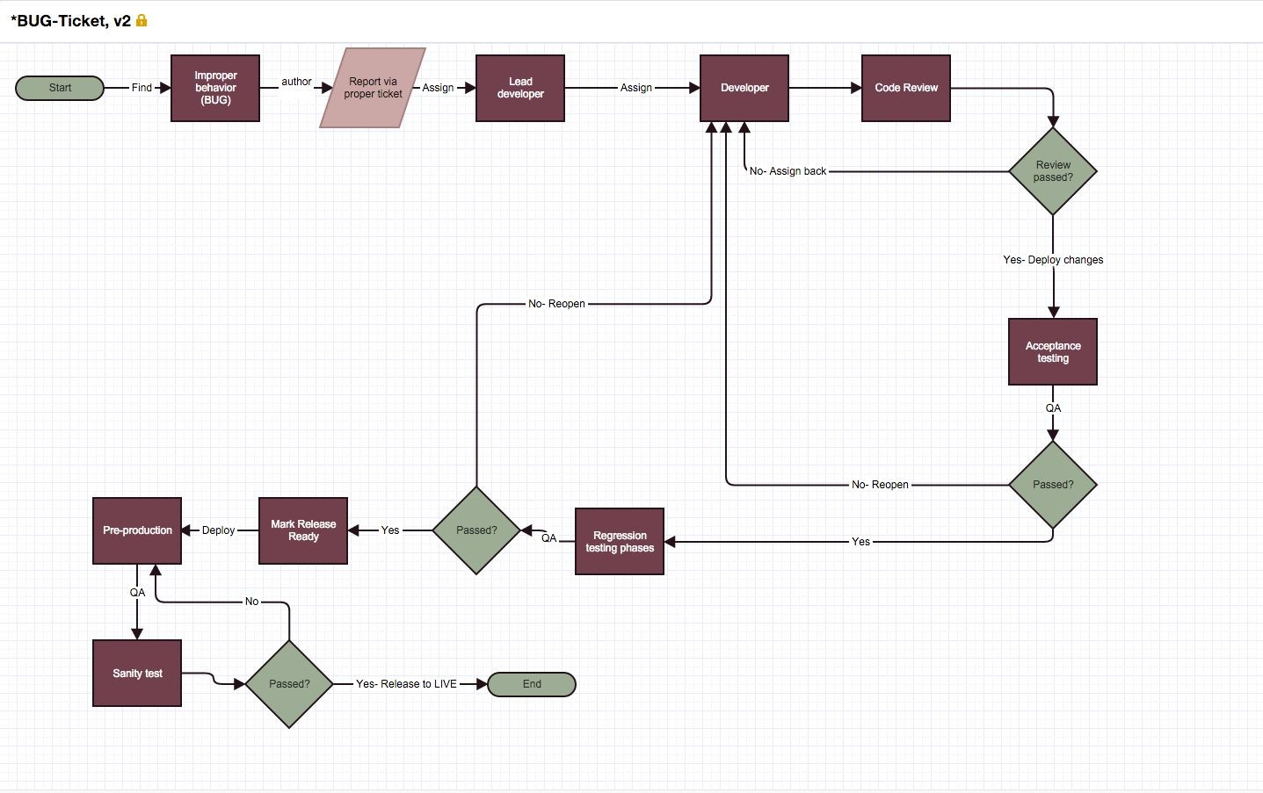

# TEST MANAGEMENT PROCESS:

## Test Design Process:

Designing the test is depending on some major factors as listed below: 1- This is a dummy text

2- This is a dummy text 3- This is a dummy text 4- This is a dummy text

## Test Execution Process:

Real execution should cover all the documented test cases which should be for each as: 1- This is a dummy text

2- This is a dummy text 3- This is a dummy text 4- This is a dummy text

## Test Risks & Dependencies:

|  |  |  |
| --- | --- | --- |
| **Risk** | **Severity** | **Back-Up** |
| Changing requirements | {{Severity}} | {{Back-up}} |
| Lack of tester | {{Severity}} | {{Back-up}} |
| Unstable testing environment | {{Severity}} | {{Back-up}} |
| Unexpected BUGs | {{Severity}} | {{Back-up}} |
| Delayed between SDLC phases | {{Severity}} | {{Back-up}} |

* 1. **Team Members Roles:**

|  |  |  |
| --- | --- | --- |
| **NAME** | **ROLE** | **TASKS** |
| Olga.U | {{role}} | {{tasks}} |
| Team members | {{role}} | {{tasks}} |
| Ahmad.M | {{role}} | {{tasks}} |
| Team members | {{role}} | {{tasks}} |
| Team members | {{role}} | {{tasks}} |

# TEST ENVIRONMENT:

## Test Stage:

This is a dummy text

## 5.1 Test Compatibility:

Testing new project will be performed for: 1- This is a dummy text

2- This is a dummy text 3- This is a dummy text 4- This is a dummy text

*All the mentioned environment should be available for each tester.*

# DEADLINES AND DELIVERABLES:

For different departments deadlines, please refer to below table:

|  |  |  |
| --- | --- | --- |
| **Phase** | **Duration** | **Note(s)** |
| Requirements | {{duration}} | {{notes}} |
| Designing | {{duration}} | {{notes}} |
| Developing | {{duration}} | {{notes}} |
| Testing & maintenance | {{duration}} | {{notes}} |
| UAT phase | {{duration}} | {{notes}} |

***Hope you get all the Info you wish***

**BEST OF LUCK TEAM!**

*Greetings From*

*QA Team*